Welcome Guests
May 3, 2026
DROP IN OFFERING PLATE

Circle: Mr. Mrs. Ms.
Name
Address

City
State
Email address

Phone:
Best time to call:

Decision today…
- Salvation
- Baptism
- Rededication
- Membership
- Other Spiritual Decision

Prayer/other requests.
__________________________________
______________________________________
Address:
Telephone:
Requested by:
Sermon Notes….
Sermon Title:
Preacher:
Scripture:
Notes:

Opportunities to Worship Together
Sunday’s
9:30 AM Sunday School
10:30 AM Worship in Sanctuary, on Youtube & Facebook
5:00 PM Youth CHILL Spot
5:30 PM Children (upstairs) & Youth (downstairs, youth room)
5:30 PM Evening Worship in the sanctuary

Wednesday Evenings at 6:30 PM
Adult Bible Study in sanctuary
Adult Choir Rehersal in choir room
Youth Bible Study in youth room
Children Studies upstairs in the children’s room


Senior Adult Day! May 3, 2026
Call to Worship “He Touched Me”
Welcome & Prayer
Offertory Hymn 560 “Oh, How I Love Jesus”
Offertory Prayer Clarence Cook
Children’s Message Adam Ellison
Message Rev. Tim Knotts
Invitation 413 “Turn Your Eyes Upon Jesus”


Welcome to our Guest Preacher,
Rev. Tim Knotts!
Today we celebrate our SENIOR ADULTS!

Welcome as they come for membership…
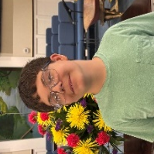
Gabe Mason
Son of Nick & Courtney Mason
Comes by profession of faith & baptism
142 Poplar Ridge Dr, Gaffney, SC 29341
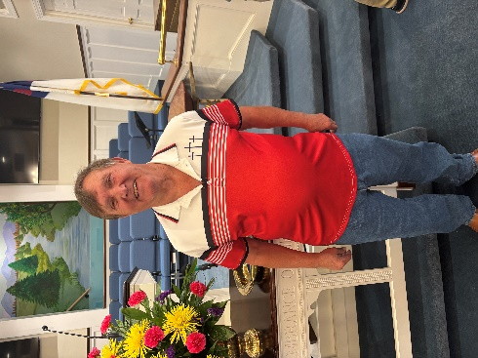
Birthday: 11/10

Jerry Sellers
Comes by profession of faith & baptism
2788 Chesnee Hwy, Gaffney, SC 29341
Birthday: 8/10



This Thursday, May 7th, we celebrate
Rev. Mark Robertson’s
3rd anniversary as Senior Pastor.

Sunday School at 9:30 AM each Sunday.
Join us next Sunday, as continue in Acts 4. God empower and emboldens us to share the gospel. Seize the Day! Come join us as we all learn together.

Men’s Bible Study
THIS Tuesday, May 5 ~ 7 PM


Winshape Camp 2026
June 22-26, 2026 at Gaffney High
Southside will be offering $150.00 towards the $275.00 Winshape Camp fee for the year 2026 for children active in the children’s ministry program at Southside. Registration has opened and spaces are limited so register as soon as possible. Winshape camp is for children who have completed grades 5K through 5th grade. For more information, see Deanna LeCroy.


JERUSALEM PROJECT 2026~ July 12-16
Participant registration deadline is June 1 - $70
Late registration after June 1 is $80.
Great opportunity to reach out and help someone in our county. More information will be coming soon.

Contact Information
Pastor: Mark Robertson 490-2119
Youth Director: Adam Ellison 219-8796
Children’s Director: Deanna LeCroy 491-3365
Church Office 489-6504
TEXT Giving 864-777-8984
Email address office@gaffneysouthside.com
Web Site www.gaffneysouthside.com
Mailing address 204 W. O’Neal Street
Gaffney, SC 29340
Office Hours M-Th, 8AM – 1PM
CCLI License No. 951189


Children’s Sunday Summer Studies
Sunday’s at 5:30 PM

Birthdays this week

Monday Landon Blanton
Tuesday Mike Cartee, Denise Scoggins, Chuck Wilborn
Wednesday Linda Martin
Saturday Brenda Harlow


Happy Anniversary!
Thursday, 5/7 Jamie & Martha Kennnington

Volunteers Week
Nursery: Jake & Morgan Robertson, if needed, Chloe Robertson
Children’s Church: Holly & Chloe Robertson
Safety Team AM: Sanctuary: Tammie McGee Patrol: Nick Mason
Safety Team PM: David Oglesby
Wednesday Safety: David Oglesby
Ushers: Rick Pearson, Josh Jackson, Steve Jolly, Matt Cook
Deacon of the Week: Clarence Cook, (864) 216-1544

-Financial Report for April 26, 2026

Tithes $7,856.80 Capital Improvement $60.00
Comedy for Cause $7000.00

Available in Capital Improvement Fund: $31,824.39

Be sure to pick up a copy of our complete prayer list to use during your prayer time this week

YOUTH End-of-School BASH
Friday, May 29 ~ 5-9 PM
See Adam Ellison for more information (864) 219-8976


Worship thru Songs
5th Sunday Singing!
Sunday, May 31st ~ 5:30 PM


KICK OFF for
SUMMER FUN DAYS!!
Thursday, June 4th
10 AM – 12:30 AM
With adventure and fun every other Thursday thur July 30th


Graduate Recognition – High School & College Sunday, May 17th ~ 10:30 AM service. If you have graduated since May 2025, we would love to celebrate with you! The following information needed as soon as possible.
NAME:
Graduate from:

Degree:

Next steps:

