
IN THE KNOW
A Mid-Week Publication

December 3, 2025
Church Office: 489.6504 office@gaffneysouthside.com
www.gaffneysouthside.com YouTube: Southside Baptist – Gaffney, SC

Youth Progressive Dinner
THIS Saturday, December 6th
Meet at the church at 3:45 PM
Bring a $20 gift for exchange at last stop.
Thank you to our hosts…Pam & Marshall Goforth, Jordan & Jeanetta Wycoff, Adam & Lacey Ellison and Greg & Kiri Shehan!


Lighting of the Christmas Trees
THIS Sunday, December 7th ~ 10:30 AM service
Special music by Bryan Horne.

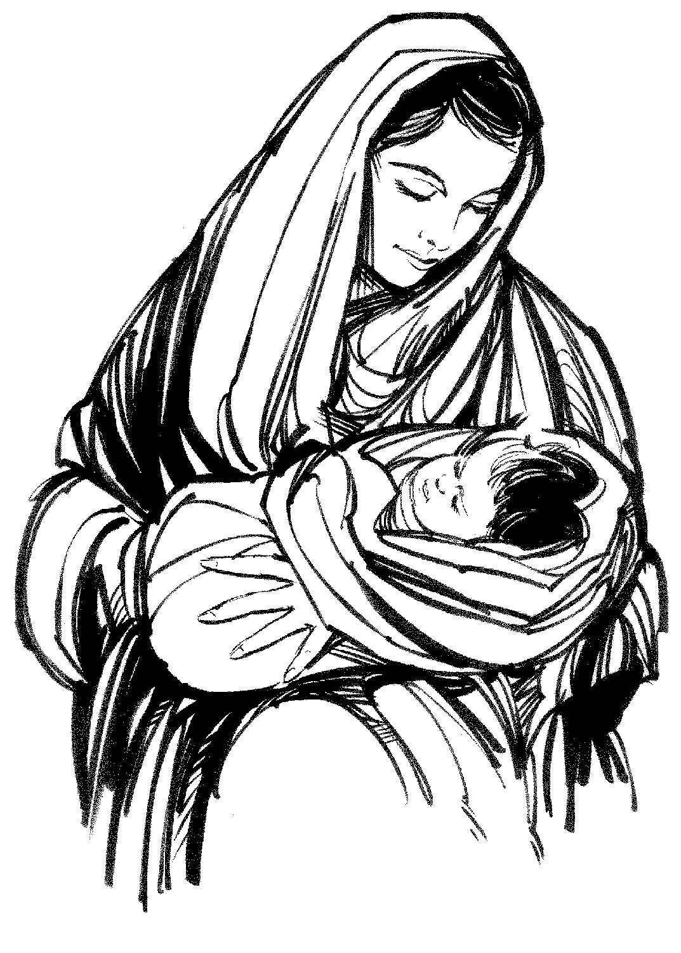
Sisters of Grace Christmas Celebration
Come learn of the women of the first Christmas.
NEXT Monday, December 8th ~ 6:00 PM


Christmas Cards for our Shut-Ins
Shut-in list is located in the ‘Gathering Place’ for your convenience. Please place their cards in their individual bags by Sunday, December 14th.

JOY Group to Midway BBQ, Saturday, Dec 13 ~ 10 AM. Sign up by Wednesday, Dec 10th

NOTE: The adult choir will be rehearsing in the sanctuary next Wednesday evening. Check your Sunday bulletin for Adult Bible Study location.

Serving & Making a Difference THIS Sunday, December 7th will be…

Baby/Toddler Nursery: Tammie McGee & Danielle Harrison, if need Holly Robertson
Children’s church: Greg & Kiri Shehan
Safety Team AM: Sanctuary: Rick Pearson Patrol: Steve Green
Safety Team PM: David Oglesby
Ushers: Adam Ellison, Steve Green, Rick Wilkins, David Oglesby
Deacon: Rick Pearson, (864) 812-0043
TONIGHT’s Safety Team is Johnny Price
PRAYER LIST – Updated December 3, 2025

Hospital Sheila Cole (Patewood) Knee replacement
Annette Parris (SMC) Sepsis
Randy Patterson (SMC) Throat cancer. Completed treatments, difficulty swallowing.

Sympathy Steven Knight family, Eric Knight’s father
Tron Foster family

Church Dale Cook – Medical test, Dec 3rd
Rick Pearson – MRI Dec 12th
Lisa Bishop – MRI on shoulder, Dec 12th
Jerry Sellers – Biopsy on prostate, Dec 15th
Oglesby Family – Sickness
Jeanetta Wycoff – Dental procedures
Dana Green – Waiting results of MRI
Raymond Yelton – Recovering from surgery.
Sheila White – Waiting results of CT scan
Jimmy Harris – Added 6 more chemo treatments
Faye Cartee – Lungs clear. To see cardiologist soon.
Marshall Goforth – Eye issues, to follow up with specialist.
Mike Childers – Back issues, nerve study
Duane & Lois Hamrick – Health issues
Pam Dickson – Ankle replacement surgery, Dec 30th
Kay Barton – Recovering from knee surgery.
Allison Wilburn – Health issues

Others Carlton Carter – Auto immune disorder.
Kim Turner – Improving from accident.
James Goforth – Recovering from valve replacement.
Tracy Blanton – Recovering from ultralight accident
Diane Pittman – Foot surgery postponed to Dec.
John Arthur – Broke arm
Wanda Morris – Health
Matt Schall – Infection on back from abcess.
Judith Hill – Cancer under hospice care

Our prayer list is long so pick up the complete list.

