
IN THE KNOW
A Mid-Week Publication

November 19, 2025
Church Office: 489.6504 office@gaffneysouthside.com
www.gaffneysouthside.com YouTube: Southside Baptist – Gaffney, SC
Shoebox UPDATE!

Thank you for helping open doors to share JESUS with children around the world. As of 11/19/2025, you have filled 79 boxes.
The boxes will go to ‘Drop-off’ location tomorrow morning.

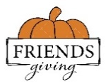
Children’s Friendsgiving
TONIGHT @ 6:30 PM upstairs in the Children’s room


Poinsettia ‘In Memory of’ or ‘In Honor of’
Envelopes are available where you pick up your bulletins COST: $13/poinsettia with Deadline will be THIS SUNDAY, November 23rd
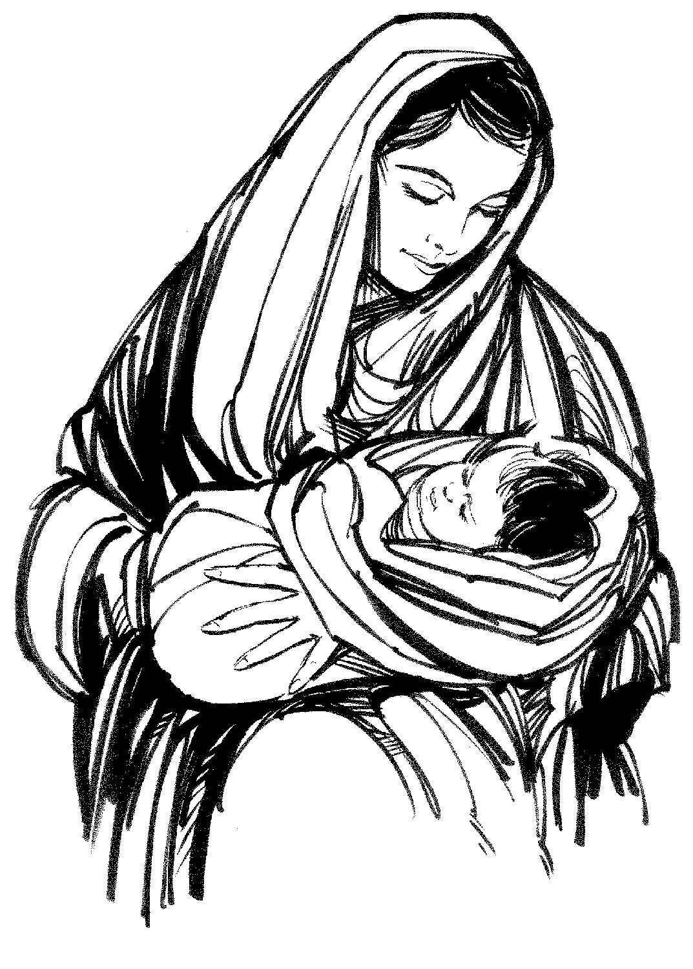
Sisters of Grace Christmas Celebration
Come learn of the women of the first Christmas.
Monday, December 1st ~

Youth Progressive Dinner ~ Saturday, December 6th
If you would like to open your home and host our youth for part of a meal, please contact Adam Ellison [864-219-8976]. We will have a stop for appetizers, salad, supper and desserts.

REMINDER, there will be NO Wednesday services, November 26th. The church office will be CLOSED next Wednesday & Thursday for Thanksgiving.

Serving & Making a Difference THIS Sunday, November 23rd will be…

Baby/Toddler Nursery: Nick & Courtney Mason, if need Dionne Durham
Children’s church: Cam & Kayla Mullinax
Safety Team AM: Sanctuary: Josh Jackson Patrol: Donald Haynes
Safety Team PM: Nick Mason
Ushers: Mike Childers, TonyThomas, Jack Gordon, Lynn Wilkins
Deacon: Donald Haynes, (864) 490-2599
TONIGHT’s Safety Team is Steve Green
PRAYER LIST – Updated November 19, 2025

Hospital Lori Turner (SMC-ICU) Major heart surgery.
Tracy Blanton (SMC) Injuried in ultralight accident

Sympathy Harlie Martin family
Mike Mullinax family

Church Marshall Goforth – Eye issues, to follow up with specialist.
Tammy Hughes – Foot issues
Mike Childers – Back issues, nerve study
Billy Corbett - Covid
Pam Dickson – Ankle replacement surgery, Dec 30th
Holly Robertson –Continue recovery, received good report
Jerry Sellers – Upcoming biopsy on prostate
Raymond Yelton – Surgery, Nov 24th.
Sheila White – CT scan, Nov 19th
Jimmy Harris – Side effects of chemo treatments
Tina Stacy – Eye issues
Martha Kennington – Procedure, Nov 24th
Dale Cook – Medical test, Dec 3rd
Allison Wilburn – Health issues

Others Matt Schall – Infection on back from abcess.
Anita Devine – Stroke. Request by Kay Pearson
Judith Hill – Cancer under hospice care
Elaine Webb – Swollen legs and redness.
Rev. James Humphries – Heart health
Cameron Mullinax – Walking pneumonia
Carley Holcomb – Recovering from gall bladder surgery
Cindy Hughey – Recovering from surgery.
Tony Spencer – Bladder cancer.
Garrett Moss – Follow up scan in February.
Evelyn Laughlin – Xrays on Nov 19th
Fran Ross – Hospice. Request by Rick Wilkins
John Fowlkes – 90 year-old with dementia.
Chad Moss – Lung problems. Request by Melinda Hulsey
Diane Pittman – Foot surgery, Nov 20th. Betty Smith’s daughter
Our prayer list is long so pick up the complete list.

