
Southside Baptist Church PRST STD
204 W. O’Neal Street U. S. Postage Paid
Gaffney, SC 29340-2142 Non-Profit Organization
Gaffney, SC 29340-9998
Permit No. 266

Return Service Requested

September/October
2025 Newsletter

E-mail address: office@gaffneysouthside.com
Website: www.gaffneysouthside.com

Opportunities to Worship Together.

SUNDAY’s
9:30 AM - Sunday School
10:30 AM - Worship in the Sanctuary. You can also watch Livestream on YouTube & Facebook
Hello Church Family!!!
Well, summer is officially over, and the kids have started back to school. Please be in prayer for students, teachers, faculty, and staff. With school starting back that means that we are officially in football season. Just think we will be spending our Friday nights cheering on our Gaffney Indians and Blacksburg Wildcats.
We do have some big events coming up in September and October and I’m excited to see what God is going to do in these events. September 21st we will be having baby dedication day. If you would like to have your baby dedicated, please let me know.
September 28th will be our ‘Family Day’, and we have our director of missions, Dr Dwight Easler coming to share with us on this special day. Please be in prayer for Dwight and pray that God will use him in a special way. Remember church family we are having a covered dish meal after the service. We are asking that you bring the sides for the meal, and the Church will be providing the meats. Let me encourage you to invite your family and friends to join us on this special day.
Coming up on October 26th we will be having our trunk or treat. This is always a fun and exciting time and the kids always look forward to it. This year we’re adding a little excitement for the adults as we will be having a chili cookoff and having judges to determine who has the best chili. Let me encourage you to provide a trunk and share in all the excitement. As always, thank you for allowing me to be your pastor.
In Christ love
Mark Robertson
5:00 PM – AWANA [Begins September 7th]
5:00 PM – Youth Chill Spot
5:30 PM - Youth Study downstairs
5:30 PM - Evening Worship in the Sanctuary

WEDNESDAY’s at 6:30 PM
Adults in sanctuary
Children’s Choir
Youth in youth room
Adult Choir in choir room

Family Day at Southside
Sunday, September 28th
10:30 AM Worship
Guest Preacher:

Dr. Dwight Easler
Covered dish meal following the morning service. Bring extra for our guests. Meats will be furnished.
There will be NO evening service on Family Day.


Clean Start date:

JOY Group Meetings

- Saturday, September 13. Bus leaves at 4 PM for Captain’s Cap Seafood, Gastonia. Sign up by Wednesday, September 10
- Saturday, October 11 ~ 4 PM in the Family Life Center. Steak Dinner. Sign up by Wednesday, October 8th.

September 27 & October 25

If you want updates and are willing to help in times of need with rides or getting things for those in need they can join this text group. Any questions, see Adam Ellison.

The church office will be CLOSED on Monday,
September 1st for Labor Day




Sunday, September 21
10:30 AM
Let the church office know by Sunday, September 14th if you would like to dedicate your child.

Season of Prayer for State Missions &
Janie Chapman Offering
~ September 7-14
Investing in the Kingdom
OUR CHURCH GOAL: $1,000.00

“Let each of you look out not only for his own interests, but also for the interests of others.”
- Philippians 2:4

Welcome as she comes for membership….
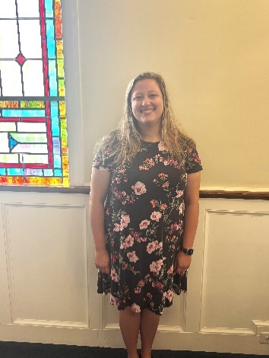
Allison Cantrell
105 Tory Trail
Cowpens, SC 29330
Birthdays: 11/17

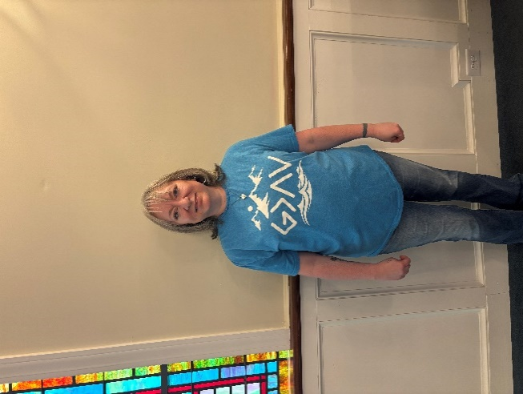
Bridget Whelchel
312 Springwood Dr
Gaffney, SC 29340
Birthdays: 4/16

Men’s NEW Bible Study
Study of John
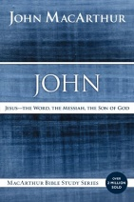
Jesus — the Word, the Messiah, the Son of God

Starts Tuesday, September 9
7:00 PM
Meeting every other Tuesday
COST: $8.50/book


Adam Ellison, (864) 219-8976

Youth
CHILL SPOT

Starts back Sunday, September 7 at 5PM in the youth room downstairs.



Wednesday, September 24th
Students gather at their schools flagpoles before school and pray for their school, fellow students, teachers.
Wednesday, September 24th
THEN that evening ONE NIGHT RALLY
They gather for county wide worship.
Time and place will be announced soon.


Youth Winter Retreat
January 18-20, 2026
DATE TO REMEMBER:
2nd payment deadline
Sunday, October 26th

Thank you for supporting the Lord’s ministry at Southside!

Capital Improvement Offering
In Memory of Annie Lee Loftis Wyatt Fayssoux
Janice L Poates

Did you know you can give by TEXT GIVING! Just text the amount you would like to give to 864-777-8984


Deanna LeCroy (864) 491-3365

Kicks-Off Sunday
September 7 5:00 PM


Children & Family
FUN NIGHT
Saturday
September 20th
6PM - 8PM

Children’s Trip to
STRAWBERRY HILL
Saturday, October 11th
Buses leaving at 2:30 PM
Returning at 5:30 PM
Sign up by
Wednesday, October 8th

September
2 Samantha Prince
4 Hayden Caughman
Crislyn Childers

Stacie Clary
6 Kyndal Jackson
Gloria Johnson
Paul W. Moss
7 Robin Ruppe
9 Sammy Crowe
Brandon Joy
Ashley Mahaffey
10 Ryan Clary
Eden Dillenger
Gracie Robertson
11 Elijah Bedynek
Pamela D Owen
Grace Sperber
Beth Walker
12 Lindsey Ellis
Chip Scoggins
Rick Wilkins
14 Larry Dengate
15 Lisa Bishop
18 Amelia Hudson
Matt Lydia
- Joel Greene
Bryn Turner
22 Makenzie Hudson
25 Natalie Brackins
26 Logan Durham
27 Courtney Mason
28 Madison Baebler

September 2  Bobby & Tina Stacey (26th)
September 8  Mike & Faye Cartee (46th)
September 10 Ron & Judy Harrill (59th)
September 14 Chip & Denise Scoggins (34th)
September 20  Matt & Stacie Clary (28th)
September 24  Terry & Jo Wilson (4th)
October 24 Jeremiah & Deanna LeCroy (10th)
Jordan Evans
29 Jesup Dillenger
30 Cassidy Holman




FallOWeen &
Chili Cook Off!
Sunday,
October 26
5:00 PM
Fun for ALL!
Ladies & Gentlemen,
get your best chili recipe out
and get ready.


October
1 Adam Floyd
2 Mallory Joy
Jemma Mabe
Ken Owen
Hunter Wylie
3 Peggy Kies
4 Austyn Ellison
Anthony Harrill
Joyce Parris
5 Evan Head
Jacob Mabe
Brenda K. Parker
6 Ron Harrill
Danielle Hawkinw
7 Parnice Lester
Terry White
10 Sheila Cole
Donnie Gates
12 Doris Dover
Bonnie Martin
14 Angie Harrill
Caleb Harrill
Mickey Gordon
Randy Smith
15 Lori Marinucci
16 Betty P Kirby
Alan McEntire
17 Cindy Bell
Mary Littleton
Matthew Thornton
18 Mark Walker
19 Margaret Love
20 Tina Anderson
Scott Bright
Connor Head
21 Mary Haynes
22 Brian Garner
Jennifer Mabe
23 Mark Harrill
26 Bobby Garner
Tony Thomas
27 David Oglesby
29 Abigail Price
James Upchurch
30 Duane Hamrick
31 Lily Grace Moore

Sheila White

