Welcome Guests
May 11, 2025
DROP IN OFFERING PLATE

Circle3: Mr. Mrs. Ms.
Name
Address

City
State
Email address

Phone:
Best time to call:

Decision today…
- Salvation
- Baptism
- Rededication
- Membership
- Other Spiritual Decision

Prayer/other requests.
__________________________________
______________________________________
Address:
Telephone:
Requested by:
Sermon Notes….
Sermon Title:
Preacher:
Scripture:
Notes:

Card Ministry for this week:
Jesup & Kelly Dillenger, Tyler & Marley Blanton,
Brittany Blackwell & Tyler Bryant
(Cards are located on the table in the Gathering Place)

Opportunities to Worship Together
Sunday’s
9:30 AM Sunday School
10:30 AM Worship in Sanctuary, on Youtube & Facebook
NO EVENING SERVICES TONIGHT

Wednesday Evenings at 6:30 PM
Adult Bible Study in sanctuary
Adult Choir Rehersal in choir room
Youth Bible Study in youth room
Children Choir upstairs in children’s room


Mother’s Day May 11, 2025

Call to Worship “I Saw the Light”
Welcome & Prayer
Prayer Concerns
Offertory Hymn 148 “He Keeps Me Singing”
Offertory Prayer Ron Harrill
Children’s Message Deanna LeCroy
Special Music Lisa Bishop
Message Rev. Mark Robertson
Invitation 412 “The Savior is Waiting”

Welcome as they came forward last Sunday and come seeking membership..
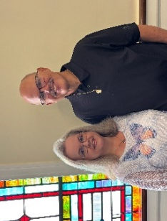
Dale & Pamela Whitt
235 James Rd
Gaffney, SC 29341

Birthday: Dale – 11/21; Pamela – 2/8
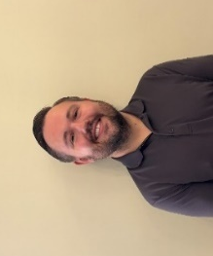
Clayton Whitt
546 Macedonia Rd, Gaffney, SC 29341

Birthday: 5/26
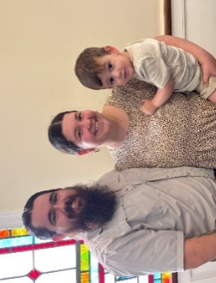
Alex & Maegan Whitt
Pictured with their son, Louie
3098 Old Georgia Hwy, Gaffney, SC 29340

Birthdays: Alex – 3/19; Maegan – 1/18; Louie – 6/11


KICKOFF Baby Bottle Campaign TODAY!
Pick up a baby bottle fill it with money and support the Cherokee Pregnancy Center. Transforming and saving lifes.


Graduate Recognition
NEXT Sunday, May 18 ~ 10:30 AM

It's that time of year again! The Caring for the Community event starts today, May 4, 2025. We'll be delivering bags of school supplies and food on August 2, 2025.
Our goal for this year is 400 school supply bags and 400 food bags. We'll have school and food bags in the choir room available if you want to fill a bag yourself, or you can give money in the offering, to Tammie McGee or to Ethan Travis McGee. It costs approximately $8 for a bag of food and $7 for a bag of school supplies. If you want to fill a bag yourself, here are the items that will be placed in the bags we buy with donated money.
School Supplies: Pencils, Glue Sticks, Crayons, Scissors, Notebooks, Folders, Notebook Paper, Pencil Pouches, Pencil Sharpeners, and Erasers
Food: Mac & Cheese, Green Beans, Tuna, Peanut Butter, Corn, Fruit, Pork n' Beans, Carrots, Peas, Soup

Contact Information
Pastor: Mark Robertson 490-2119
Youth Director: Adam Ellison 219-8796
Children’s Director: Deanna LeCroy 491-3365
Church Office 489-6504
TEXT Giving 864-777-8984
Email address office@gaffneysouthside.com
Web Site www.gaffneysouthside.com
Mailing address 204 W. O’Neal Street
Gaffney, SC 29340
Office Hours M-Th, 8AM – 1PM

Birthdays this week

Monday Sylvie Cook, James Lester
Tuesday Danny Higgins, Bobby Stacey
Wednesday Marley Blanton
Thursday Adalee Ellison, Deborah Hughey
Friday Kelly Towery
Saturday Dalton Joy, Angie Peterson


Happy Anniversary!
Sunday, 5/11  Jesup & Kelly Dillenger (7th)

Volunteers This Week
Nursery: Lacey Ellison & Myra McCoy
NO Children’s Church
Safety Team AM: Sanctuary: Rick Pearson Patrol: Steve Green
Wednesday PM: Davie Oglesby
Ushers: Adam Ellison, Steve Green, Rick Wilkins, David Oglesby
Deacon of the Week: Ron Harrill, 838-8502

Financial Report ~ 5/4/2025

Tithes $ 7,114.10 Capital Improvement $ 60.00
Care Community $30.00 Ramp/Wheelchair $ 50.00
Children’s Ministray $ 25.00 Comedy for a Cause $2,840.00

Available in Capital Improvement Fund: $20,379.51


INFORMATION…We are changing text message apps due to ‘Remind’ no longer offering that service. Be sure to follow the church Facebook page for updates from the leaders. They are currently working on a new app.


Youth OPEN Gym Night
Saturday, May 24 ~ 6 pm - 8 pm


Bibles Studies THIS Monday, May 12
6 PM – Ladies meeting in the main building
6:30 PM – Men meeting in the Family Life Center

Men By Design
THIS Tuesday, May 13
6:30 PM @ Corinth Baptist
MENU: Chicken/Ribs
COST: $15


Jerusalem Project
July 14-18 ,2025

Participant registration fee:
$35 due May 28
After June 1st, registration is $80.

Jerusalem Project also needs ADULT VOLUNTEERS… Crew Chiefs & Crew Encouragers. For more information, check out applyforjp.com

CHURCH COUNCIL Meeting
Sunday, May 18 ~ 4 PM
In the Library
We will look at July, August and September activities.

NOTE…July/Aug Newsletter information must be in the church office by June 4th.

